1 Naming test plan as Junit sampler test plan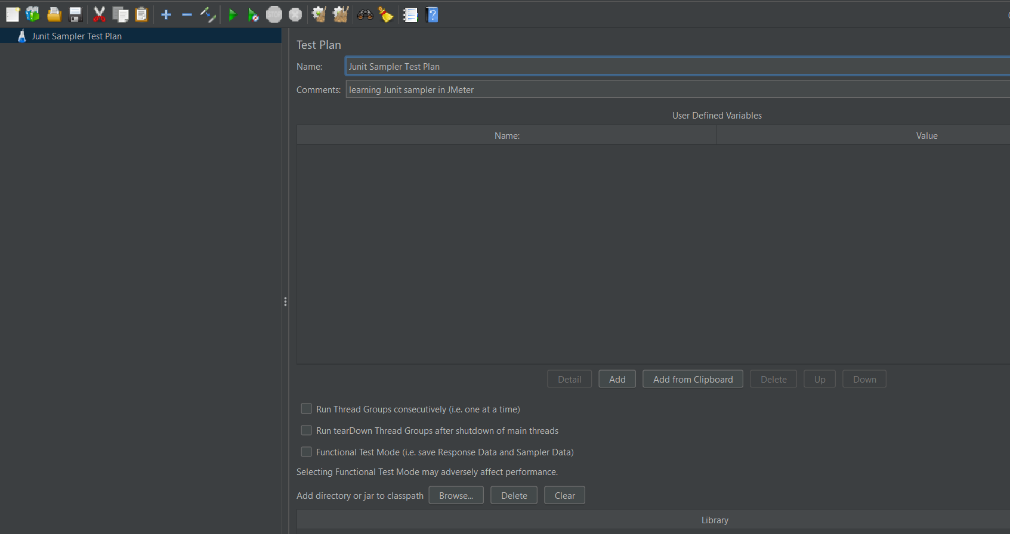

Step 2 – Right click on test plan ,click on Add ,Then click on threads, click on thread group

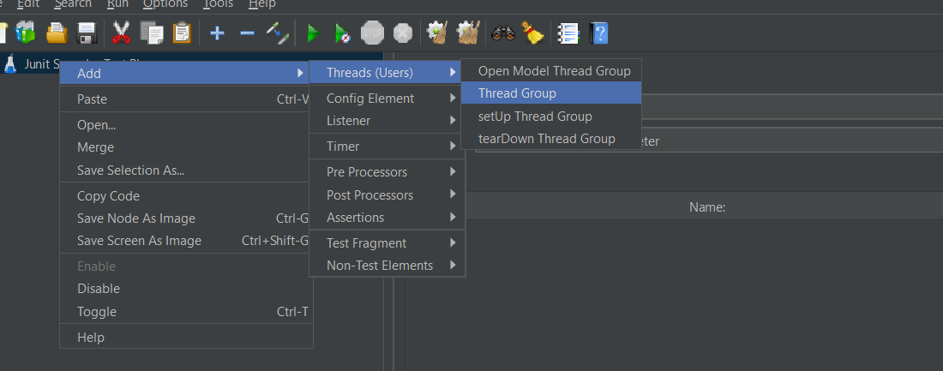

Step 3🡪Right click on Thread Group then click on add and click on sampler and click on junit sampler.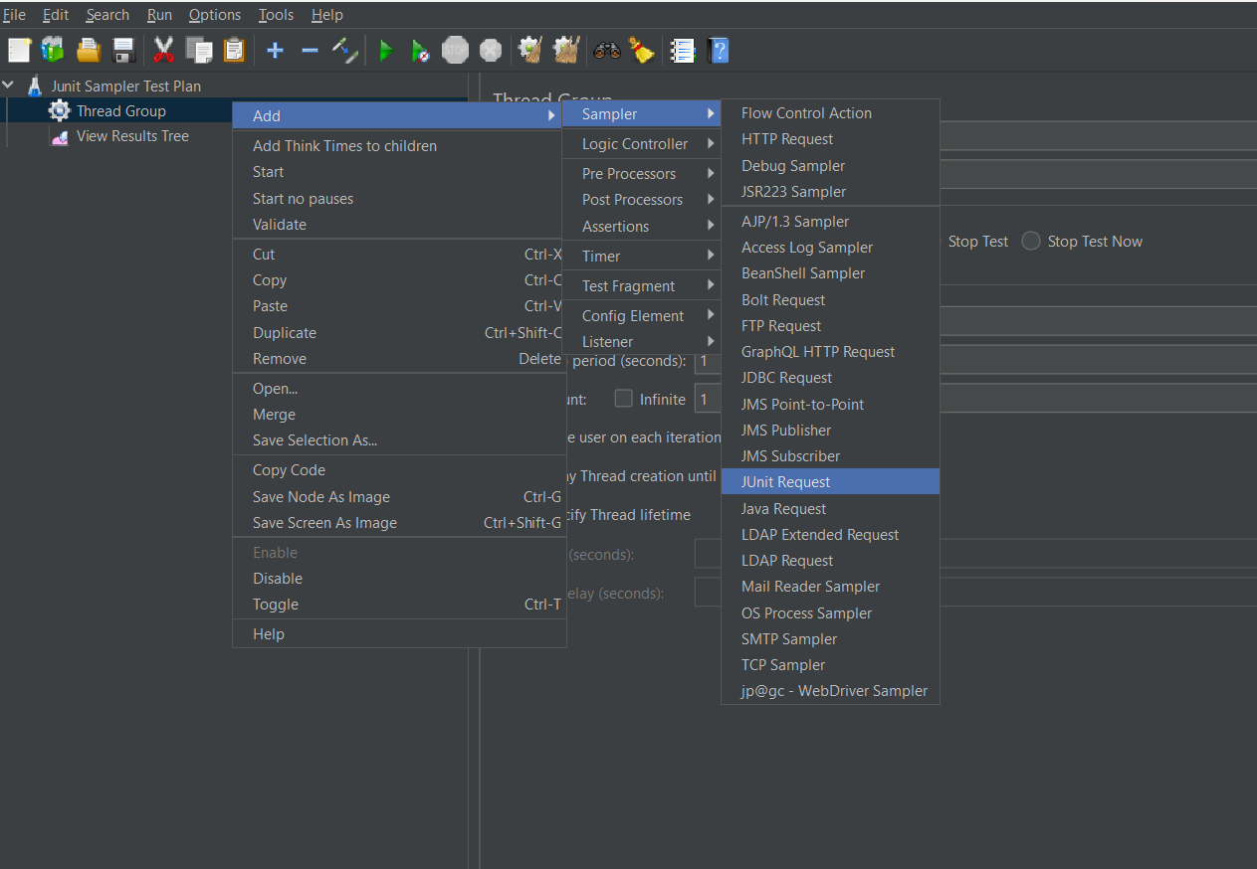

Step 4 🡪right click on Thread Group and click on add then click on the listener then click on view result tree.

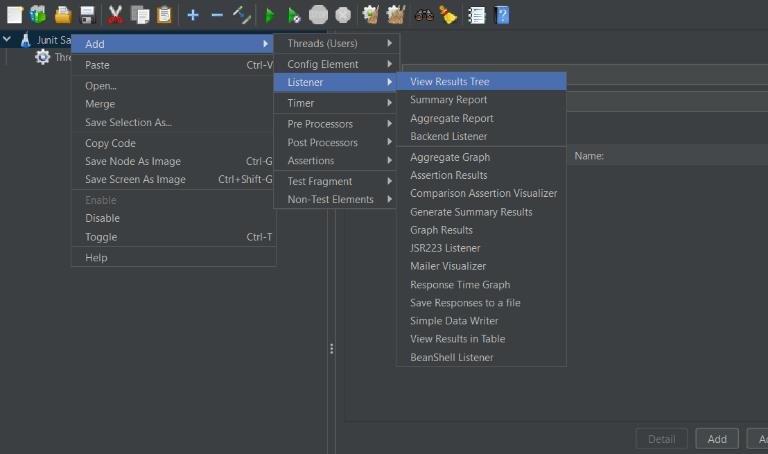

Create a java package in eclipse

Create a Junit class in src folder and add Junit Test annotations🡪create a junit method

Add Junit 4 in it.

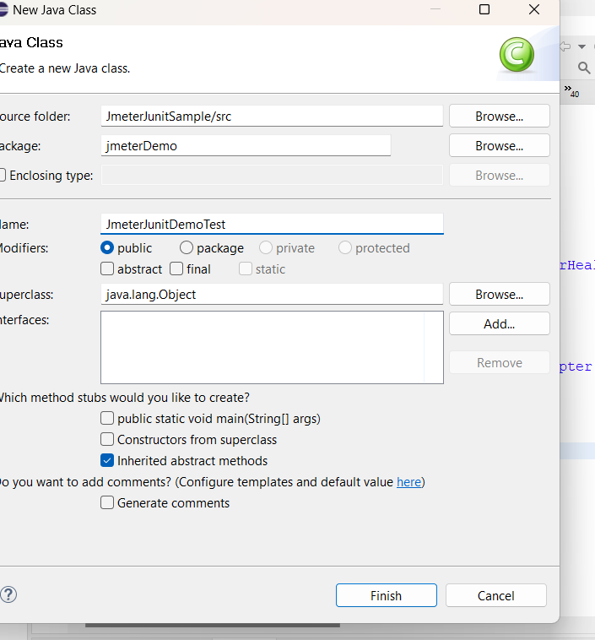

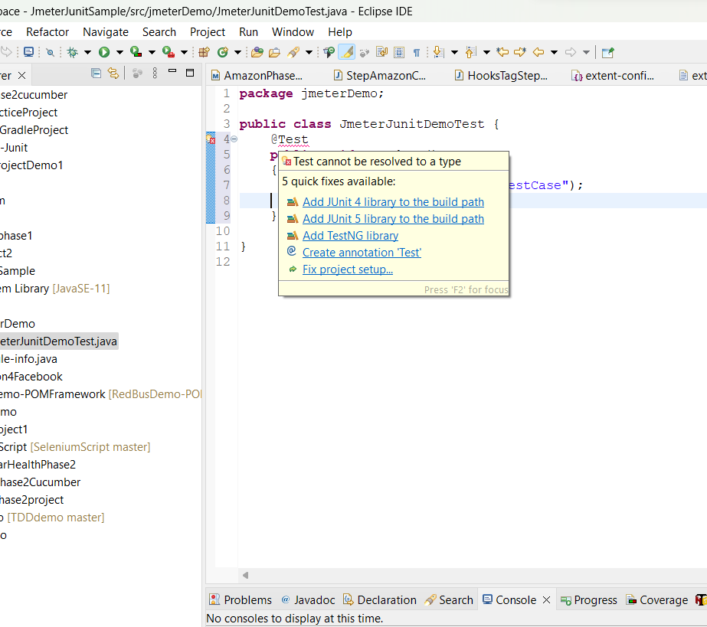

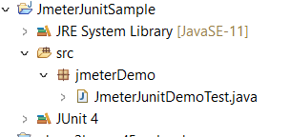

Steps🡪 4 right click on the project 🡪click on export🡪 select on JAVA (JAR File ) 🡪click on next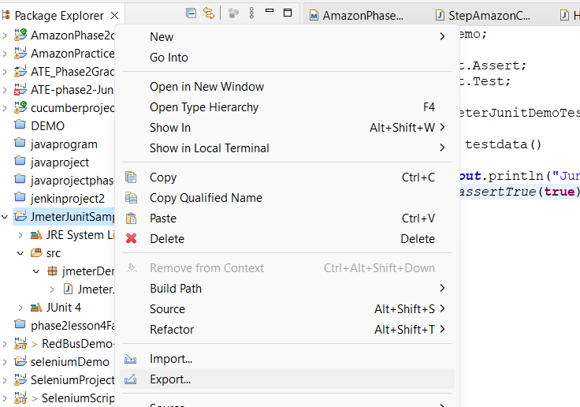

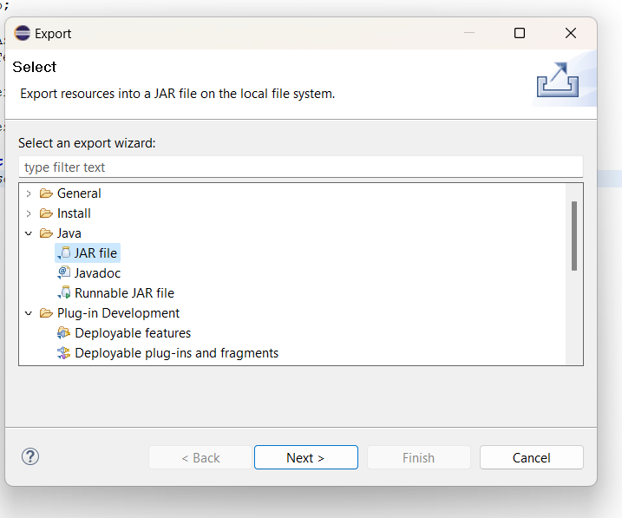

Steps🡪select the path of apache-jmeter folder (in lib folder there will be junit ),click browse button then save the file with “ .jar”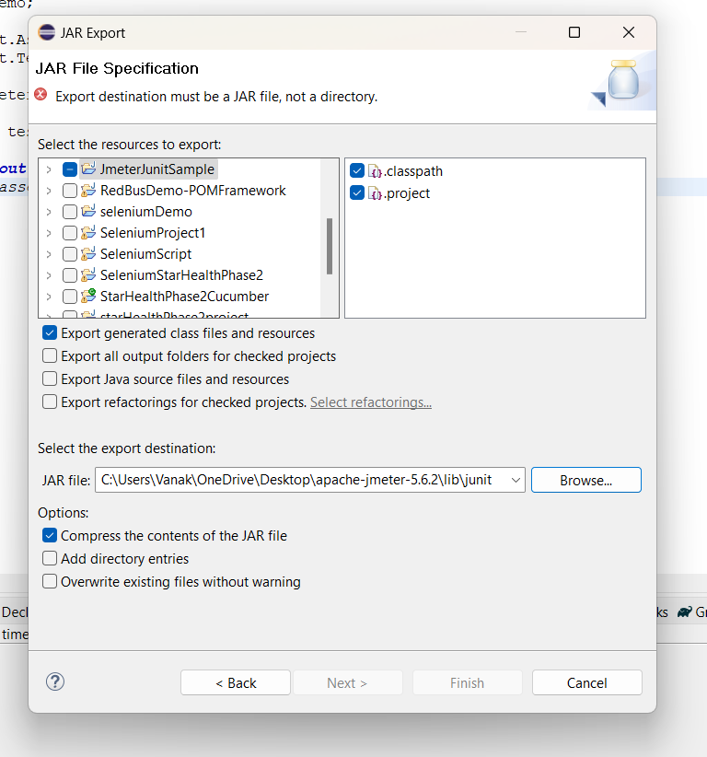

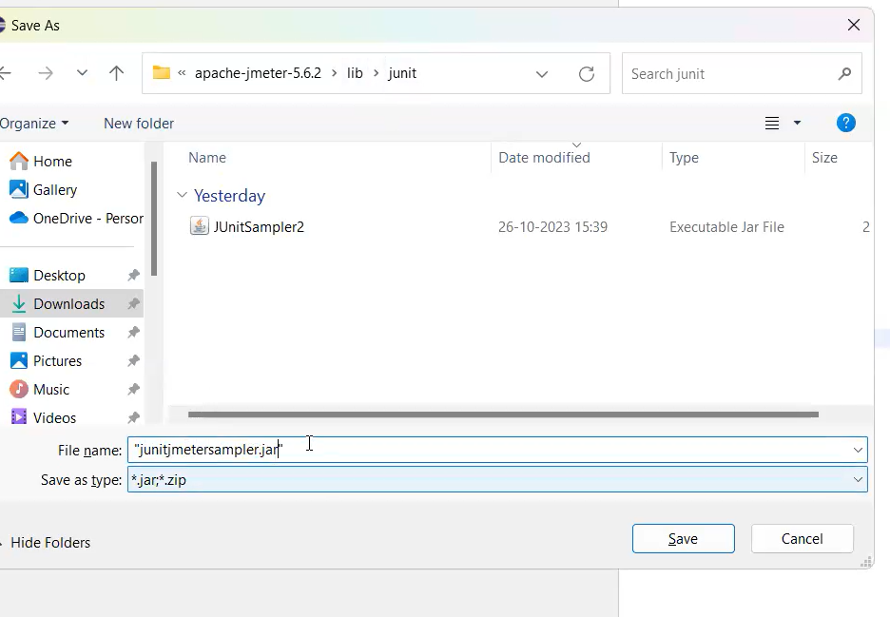

In jdbc request click the tick box,then u can see filename in class name box

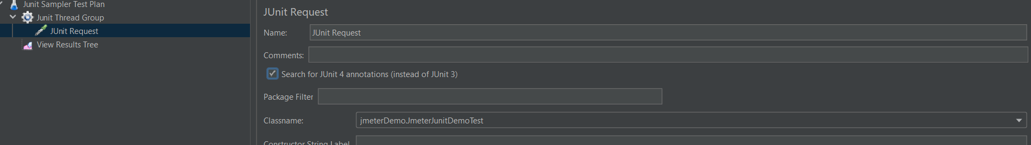

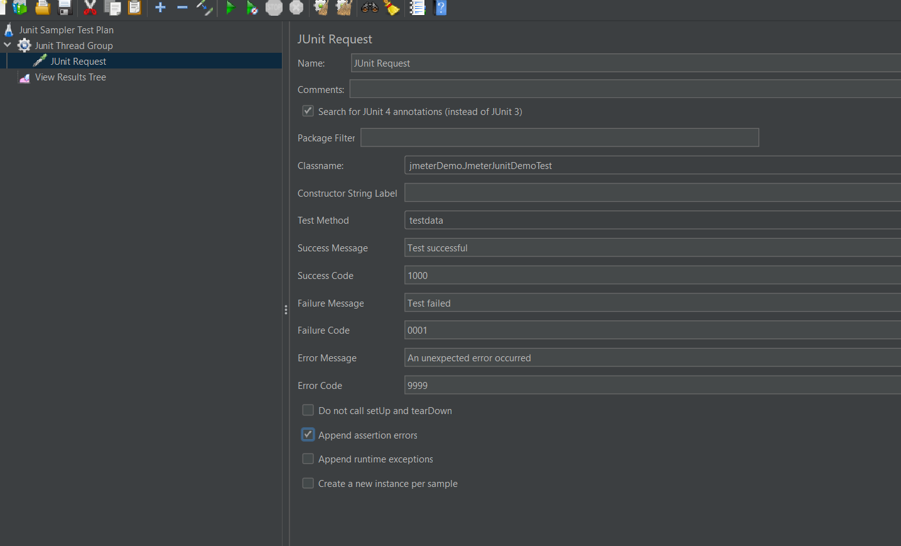

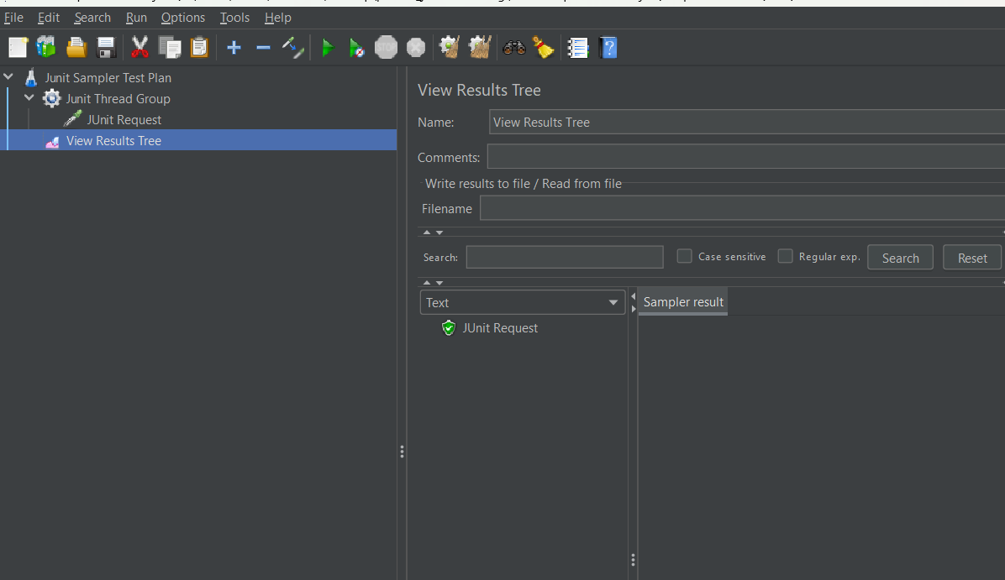

Click on run button.